**How set Global Home for Java/Maven:**

login with: sudo su -

[ec2-user@ip-172-31-31-132 ~]$ sudo su –

Add hostname: e.g. if this is Tomcat server and instance tag name also updated accordingly

[root@ip-172-31-31-132 ~]# hostname Tomcat

Login back as su to make hostname effective:

[root@ip-172-31-31-132 ~]# sudo su –

[root@Tomcat ~]# yum update -y

Install Java8:

[root@Tomcat ~]# yum install java-1.8* -y

Set Java Home:

Search Java location:

1st Method:

# find /usr/lib/jvm/java-1.8* | head -n 3

(Java path is shown with Instance Type e.g. Amazon

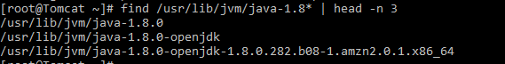

2nd Method

[root@Tomcat ~]# whereis java

java: /usr/bin/java /usr/lib/java /etc/java /usr/share/java /usr/share/man/man1/java.1.gz

Java is inside JVM container and this is way we can identify java location,

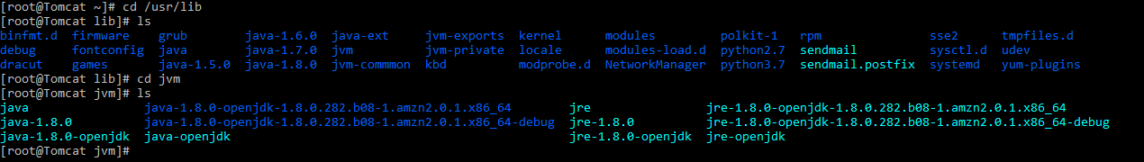

# java -version

openjdk version "1.8.0_282"

OpenJDK Runtime Environment (build 1.8.0_282-b08)

OpenJDK 64-Bit Server VM (build 25.282-b08, mixed mode)

**Set Java/Maven Home so that it can be located globally:**

We edit the bash profile

This is the orginal Bash Profile:

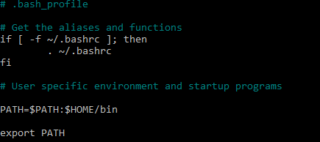

Set the Java Home Path:

Java location is /usr/lib/jvm/java-1.8.0-openjdk-1.8.0.282.b08-1.amzn2.0.1.x86_64 so we add the line below uner User specific environment.

JAVA_HOME=/usr/lib/jvm/java-1.8.0-openjdk-1.8.0.282.b08-1.amzn2.0.1.x86_64

Now change the PATH environment by adding the Java Home definition:

PATH=$PATH:$HOME/bin:JAVA_HOME

The updated Java Global profile will is below:

# nano ~/.bash_profile

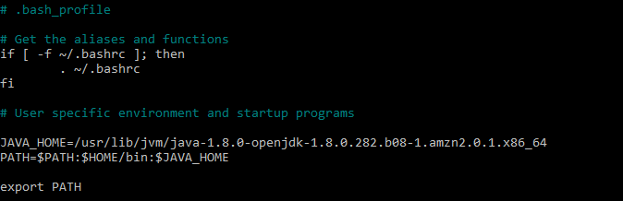

Save the environment:

# source ~/.bash_profile

Now the Java is set globally:

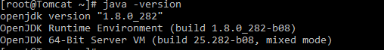

**Set the Maven Global Home variable:**

Locate the Maven Installation: e.g. we have installed Maven in /opt/maven folder then path is-

/opt/maven/apache-maven-3.6.3/bin

Edit the bash profile and update it by using Maven folder M2.

**M2**: A settings. xml file that contains global settings for all **maven** executions.

Add below in bash profile:

M2_HOME=/opt/maven/apache-maven-3.6.3

M2=/opt/maven/apache-maven-3.6.3/bin

PATH=$PATH:$HOME/bin:$JAVA_HOME:$M2_HOME:$M2

# nano ~/.bash_profile and # source ~/.bash_profile

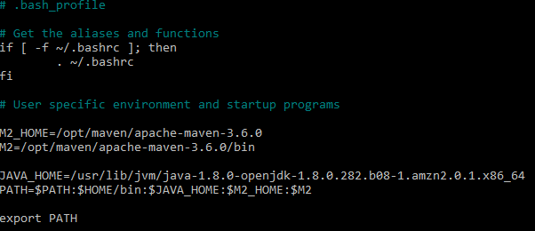

Verify Maven Installation:

# mvn -v

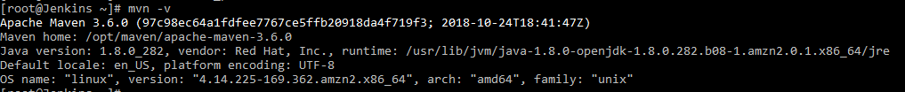

# mvn clean package

(This is the best way to ensure Maven Path is correct as we actually build Maven this way in the Jenkins Build job)